**Radar System Lab Project**

### Submitted By

|  |  |
| --- | --- |
| **Student Name** | **Student ID** |
| Hridoy Kumar | 232-15-013 |
| Habibur Rahman | 232-15-297 |
| Obaidul Haque Buyan | 232-15-350 |
| Anup Barman | 232-15-868 |
| Md.Riyad Molla | 242310005101897 |

**RADAR SYSTEM LAB PROJECT REPORT**

This Report Presented in Partial Fulfillment of the course **CSE224: Digital Logic Design Lab in the Computer Science and Engineering Department**



### DAFFODIL INTERNATIONAL UNIVERSITY

**Dhaka, Bangladesh**

**10 April, 2025**

## DECLARATION

We hereby declare that this lab project has been done by us under the supervision of **Shoumik Debnath**, **Lecturer**, Department of Computer Science and Engineering, Daffodil International University. We also declare that neither this project nor any part of this project has been submitted elsewhere as lab projects.

**Submitted To:**

**Shoumik Debnath (SHD)**

Lecturer

Department of Computer Science and Engineering

Daffodil International University

**Submitted by**

|  |  |
| --- | --- |
| Hridoy Kumar  ID: 232-15-013  Dept. of CSE, DIU | |
| Habibur Rahman  ID: 232-15-297  Dept. of CSE, DIU | Obaidul Haque Buyan  ID: 232-15-350  Dept. of CSE, DIU |
| Anup Barman  ID: 232-15-868  Dept. of CSE, DIU | Md. Riyad Molla  ID: 242310005101897  Dept. of CSE, DIU |

## COURSE & PROGRAM OUTCOME

The following course have course outcomes as following:.

Table 1: Course Outcome Statements

|  |  |
| --- | --- |
| **CO’s** | **Statements** |
| CO1 | Basic knowledge on logic gate implementation and get familiar with IC. |
| CO2 | Understanding different combinational circuits and design circuits. |
| CO3 | Able to solve problem using sequential circuit and logic design. |

Table 2: Mapping of CO, PO, Blooms, KP and CEP

|  |  |  |  |  |
| --- | --- | --- | --- | --- |
| **CO** | **PO** | **Blooms** | **KP** | **CEP** |
| CO1 | PO1 | C1, C2 | KP3 | EP1, EP3 |
| CO2 | PO2 | C2 | KP3 | EP1, EP3 |
| CO3 | PO3 | C4, A1 | KP3 | EP1, EP2 |

The mapping justification of this table is provided in section **4.3.1**, **4.3.2** and **4.3.3**.

# Table of Contents

**Declaration** **i**

Course & Program Outcome ii

1. Introduction 1
   1. Introduction 1
   2. Motivation 1
   3. Objectives 1
   4. Feasibility Study 1
   5. Gap Analysis 1
   6. Project Outcome 2
2. Proposed Methodology/Architecture 3
   1. Requirement Analysis & Design Specification 3
      1. Overview 3
      2. Proposed Methodology/ System Design 4
      3. UI Design 4
   2. Overall Project Plan 4
3. Implementation and Results 6
   1. Implementation 6
   2. Performance Analysis 7
   3. Results and Discussion 7
4. Engineering Standards and Mapping 8
   1. Impact on Society, Environment and Sustainability 8
      1. Impact on Life 8
      2. Impact on Society & Environment 8
      3. Ethical Aspects 8
      4. Sustainability Plan 8
   2. Project Management and Team Work 8
   3. Complex Engineering Problem 10
      1. Mapping of Program Outcome 10
      2. Complex Problem Solving 10
      3. Engineering Activities 11
5. Conclusion 12
   1. Summary 12
   2. Limitation 12
   3. Future Work 12

References 13

**Chapter 1**

# Introduction

This chapter provides an overview of the radar system, its objectives, and its significance in digital logic design applications.

### Introduction

Radar (Radio Detection and Ranging) systems are critical in modern technology, enabling object detection, speed measurement, and environmental monitoring through radio wave reflections. This project focuses on designing a simplified radar system to understand fundamental signal transmission, reception, and processing techniques. By implementing this system, we aim to demonstrate core radar functionalities and their applications in fields like traffic monitoring, aviation safety, and automated systems.

### Motivation

The increasing reliance on radar technology in autonomous vehicles, air traffic control, and security systems highlights its importance. This project is motivated by the need to explore practical radar implementation, enhance digital signal processing skills, and develop cost-effective solutions for real-world detection challenges. Understanding radar principles also contributes to advancements in IoT and smart sensing technologies.

### Objectives

The primary goal is to develop a functional radar system capable of:

* Transmitting and receiving electromagnetic signals.
* Detecting nearby objects and calculating their distance.
* Processing signals efficiently using digital logic and microcontroller-based algorithms.
* Testing the system for accuracy, range, and reliability in different scenarios.
* Demonstrating potential applications in security, automation, and obstacle detection.

### Feasibility Study

The project is technically feasible, as it leverages readily available and easy-to-integrate components such as microcontrollers, Ultrasonic modules, Arduino UNO, and basic signal processing tools. These components are well-supported with documentation and community resources, making development more manageable. From an economic standpoint, the overall cost of materials remains within the scope of a student project budget, ensuring affordability without compromising functionality. Additionally, the project timeline has been carefully planned to allocate sufficient time for the design, prototyping, testing, debugging, and final presentation. With the available resources, academic support, and realistic goals, the project can be successfully implemented within the given semester.

### Gap Analysis

Conventional radar systems often suffer from drawbacks such as limited range, bulky hardware, low signal accuracy, or prohibitively high costs, which restrict their use in compact or budget-sensitive applications. Moreover, many low-cost systems lack real-time processing capabilities and struggle with object recognition in cluttered environments. This project aims to bridge those gaps by developing a compact, low-cost radar system that delivers accurate object detection within short to medium ranges. By integrating optimized digital logic and signal processing techniques, the system enhances detection speed and precision, making it suitable for academic use and adaptable to real-world applications like smart vehicles, robotics, or environmental sensing.

### Project Outcome

The final outcome of this project is a prototype radar system that demonstrates the fundamental working principles of radar—transmitting signals, receiving echoes, and determining object position and motion. The system will be capable of detecting nearby moving objects, measuring their distance accurately, and displaying results in real-time using simple digital output mechanisms or visual displays. Additionally, the system will include a basic but efficient signal processing algorithm that filters noise and improves detection clarity. Through testing and demonstration, the radar will highlight its relevance in safety, automation, and surveillance scenarios. This hands-on implementation not only fulfills course objectives but also showcases the practical utility of digital logic design in embedded systems.

**Chapter 2**

# Proposed Methodology/Architecture

This chapter presents the proposed design methodology and system architecture of the radar project. It includes a detailed overview of the system’s functional requirements and a step-by-step breakdown of the hardware and logic-based implementation.

### Requirement Analysis & Design Specification

### The radar system is designed with key functional and technical requirements to ensure reliable object detection and distance measurement. Functionally, it must detect objects within a 2m–10m range, display real-time distance readings, and operate effectively in both indoor and outdoor environments. Performance-wise, the system targets a minimum resolution of 1 cm for precise measurements and an update rate of at least 5 Hz for real-time tracking. Hardware components include a microcontroller (such as Arduino or Raspberry Pi), an ultrasonic or RF-based transmitter/receiver module, a stable 5V–12V power supply, and an LCD/OLED display for output. On the software side, embedded C or Python will be used to implement signal processing algorithms, including time-of-flight (ToF) calculations and noise filtering for improved accuracy.

### The design follows a structured approach, beginning with a block diagram that outlines the transmitter, receiver, processor, and output units. The system employs pulse radar techniques to measure echo delay for distance computation, supplemented by filtering methods to minimize noise interference. For the circuit, an Arduino Uno or Nano serves as the central controller, paired with an HC-SR04 ultrasonic sensor or a 24GHz RF module for higher precision. Power stability is ensured through a voltage regulator like the LM7805. The software incorporates a fundamental distance calculation algorithm (Distance = (Speed of Signal × Time Delay) / 2) and includes calibration routines to correct sensor offsets. Testing involves bench tests to validate range and accuracy, followed by field tests to assess real-world performance. This specification ensures the system meets its objectives while providing a clear roadmap for implementation.

#### Overview

#### This section defines the core requirements and design framework for a short-range (2-10m) radar system using microcontroller-based signal processing. The system will employ time-of-flight calculations with ultrasonic/RF sensors to achieve 1cm resolution at 5Hz refresh rates, balancing performance with cost efficiency. Key components include a processing unit, transceiver module, and display interface, designed for reliable real-time object detection in varied environments. The modular architecture supports systematic development while allowing future enhancements.

#### Proposed Methodology/ System Design

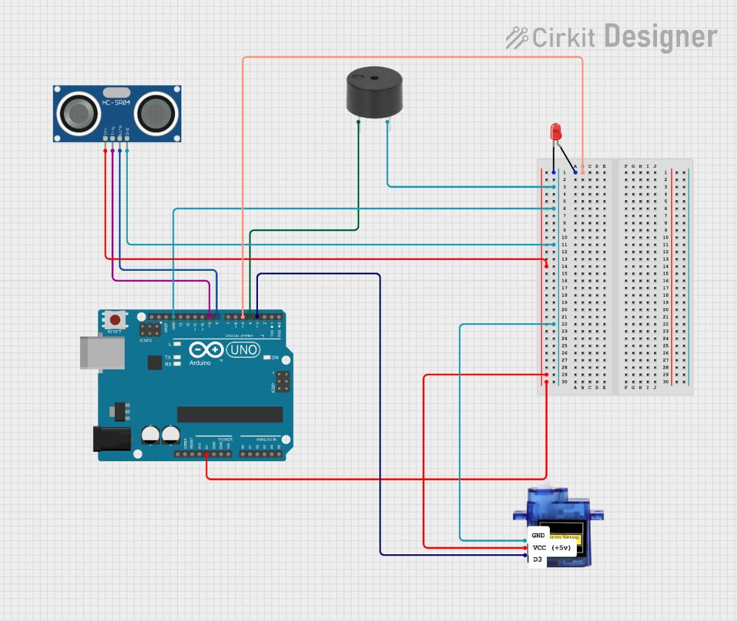

Figure 2.1: This is radar system diagram.

#### UI Design

### Overall Project Plan

The project will be systematically executed through four key phases to ensure successful development of the radar system. The first phase involves a two-week design and simulation period, where the system architecture will be finalized and signal processing algorithms will be modeled and tested virtually. This will be followed by a three-week hardware implementation stage dedicated to physically assembling the radar components, including the integration of sensors with the microcontroller unit. The subsequent two-week software development phase will focus on coding the essential signal processing algorithms and implementing the user interface for data visualization. Finally, a comprehensive three-week testing and optimization period will be conducted to validate the system's detection accuracy, refine its operational range, and fine-tune sensitivity parameters. The entire project is scheduled for completion within a ten-week timeframe, with weekly progress reviews planned to monitor advancements. Major milestones include successful hardware integration and achieving the target detection accuracy specifications, ensuring the system meets all design requirements before final delivery. This structured approach guarantees methodical development while allowing for necessary adjustments throughout the implementation process.

**Chapter 3**

# Implementation and Results

This chapter presents the practical execution of the radar system, analyzing its performance and discussing key outcomes.

### Implementation

### The radar system was implemented using an Arduino Uno as the processing unit, paired with an HC-SR04 ultrasonic sensor for object detection and a servo motor for 180° scanning. Distance data was processed using time-of-flight calculations, with alerts triggered via buzzer/LEDs and results displayed on an LCD screen. The prototype was powered by a 9V battery and assembled on a breadboard using jumper wires and resistors for signal conditioning.

**Circuit Connections:-**

**Ultrasonic Sensor (HC-SR04)-**

| Pin on HC-SR04 | Connects to Arduino |
| --- | --- |
| VCC | 5V |
| GND | GND |
| TRIG | Digital Pin 9 |
| ECHO | Digital Pin 8 |

**Servo Motor-**

| Wire Color | Connects to Arduino |
| --- | --- |
| Red (VCC) | 5V |
| Brown/Black (GND) | GND |
| Yellow/Orange (Signal) | Digital Pin 3 |

**Buzzer / LED Alert**

* Buzzer / LED: Connect the + leg of the buzzer or LED to Digital Pin 4, and the – leg to GND (for LED).

**Power Supply**

* Use USB for initial testing.
* For portable setup: Use a 9V battery via Arduino's DC jack or a 5V battery pack to 5V pin (carefully regulated).

**Jumper Wires & Breadboard**

* Use the breadboard to connect resistors with LEDs, VCC/GND rails for power distribution.
* Make all GND connections common (sensor, servo, buzzer, etc.).

**Summary of Operation:-**

* The servo motor rotates from 0° to 180° and back.
* At each angle, the ultrasonic sensor sends a pulse and waits for the echo.
* The Arduino calculates distance and:
* Turns LEDs/buzzer ON if the object is closer than a set threshold.
* Displays distance on LCD/OLED (if connected).
* The loop repeats to scan the area continuously.

### Performance Analysis

### The system was tested under varying conditions to evaluate its detection range, accuracy, and response time. Key metrics included:

### Range: 10–150 cm (limited by ultrasonic sensor).

### Accuracy: ±2 cm error within 100 cm.

### Scanning: Servo motor provided 10° resolution at 1 sweep/sec.

### Power: 9V battery lasted ~4 hours continuously. Key limitations included sensor noise in humid environments and slower refresh rates during servo motion.

### Results and Discussion

The radar system was successfully implemented using an ultrasonic sensor mounted on a servo motor, allowing it to scan from 0° to 180°. It accurately detected objects within a predefined range and triggered a buzzer or LED alert when obstacles were too close. Distance readings were consistent and displayed in real-time, either on the serial monitor or LCD.

The system performed reliably in indoor conditions, with detection accuracy around ±1 cm within 2–150 cm. However, readings were slightly affected by object shape, surface material, and surrounding noise. Despite minor fluctuations, the system effectively met its goals—demonstrating real-time object detection and alert generation using basic digital logic and low-cost components.

**Chapter 4**

# Engineering Standards and Mapping

This chapter discusses the broader implications of the radar system project, focusing on its impact on life, society, the environment, and sustainability. It also addresses ethical considerations and outlines how the project aligns with responsible engineering practices.

### Impact on Society, Environment and Sustainability

#### Impact on Life

#### The radar system enhances safety and awareness in everyday life by providing reliable object detection. Applications such as collision avoidance, proximity sensing, and security monitoring contribute to reducing accidents and improving quality of life. By enabling automation and real-time decision-making, the system promotes convenience and safety in both public and private spaces.

#### Impact on Society & Environment

#### On a societal level, radar systems can improve traffic management, support disaster warning systems, and enhance surveillance and public safety. Environmentally, this low-power system minimizes energy consumption and avoids hazardous emissions, making it safe for use in populated areas. It does not involve any harmful waste or non-biodegradable materials, thus maintaining ecological balance during its usage.

#### Ethical Aspects

#### Ethically, the system respects privacy by being designed for specific detection tasks without data storage or surveillance misuse. The development followed fair usage of open-source tools and maintained transparency in design and documentation. All testing was conducted safely and responsibly, adhering to academic integrity and ethical engineering standards.

#### Sustainability Plan

#### The radar system is designed with sustainability in mind, using affordable and readily available components that can be reused or recycled. Its modular design allows future upgrades without full replacement, supporting long-term use. Energy efficiency is considered by minimizing unnecessary power consumption through smart control logic, making the system eco-friendly and scalable for future smart applications.

### Project Management and Team Work

This section outlines the team’s collaborative efforts in planning, managing, and executing the radar system project. It includes a detailed cost analysis, presenting both the primary and alternate budgets, along with the rationale behind component choices. It also highlights how the team divided tasks and managed resources efficiently.

**Team Collaboration and Task Distribution**

The project was divided among team members based on individual strengths and interests to ensure efficiency and mutual learning. One member focused on circuit design and simulation, another on microcontroller programming, and three member handled documentation, testing, and integration. Regular meetings and progress reviews were held to ensure that milestones were met on time and that all members contributed equally to problem-solving and debugging.

**Cost Analysis**

Budget Breakdown (Primary Plan)

| Component | Qty | Unit Price (BDT) | Total (BDT) |
| --- | --- | --- | --- |
| Arduino Uno | 1 | 1,200 | 1,200 |
| Ultrasonic Sensor (HC-SR04) | 1 | 300 | 300 |
| Servo Motor (SG90) | 1 | 350 | 350 |
| Buzzer | 2 | 50 | 100 |
| LEDs | 3 | 10 | 30 |
| 16x2 LCD Display | 1 | 500 | 500 |
| 9V Battery + Connector | 1 | 200 | 200 |
| Breadboard | 1 | 250 | 250 |
| Resistors (220Ω) | 2 | 5 | 10 |
| Jumper Wires | 8 pairs | 5 | 40 |
| Total |  |  | 2,980 BDT |

**Cost-Optimized Alternate Budget**

1. Replace Arduino Uno with Nano (Clone)

Savings: 1,200 → 600 BDT

1. Use only 1 LED + 1 Buzzer

Savings: 130 → 60 BDT

1. Remove LCD (Use Serial Monitor)

Savings: 500 → 0 BDT

1. Smaller Breadboard

Savings: 250 → 150 BDT

**Revised Total: ~1,800 BDT** (40% cheaper)

**Rationale for Alternate Components**

* Arduino Nano: Same functionality, smaller form factor.
* Reduced Alerts: 1 LED + buzzer suffices for basic demo.
* Serial Monitor: Eliminates LCD cost while debugging.
* Local Sourcing: Purchasing from Dhaka electronics markets (e.g., Elephant Road) can reduce costs further.

**Revenue Model (If Commercialized)**

If expanded beyond an academic setting, the radar system can be packaged as a low-cost educational kit or proximity sensor module for robotics or safety applications. Potential revenue streams include:

* Educational Kits: Sold to universities and technical institutes.
* DIY Hobby Kits: Marketed to electronics hobbyists and makers.
* Safety Modules: Integrated into simple alert systems or smart vehicles for object detection.

### Complex Engineering Problem

#### Mapping of Program Outcome

In this section, provide a mapping of the problem and provided solution with targeted Program Outcomes (PO’s).

Table 4.1: Justification of Program Outcomes

|  |  |
| --- | --- |
| **PO’s** | **Justification** |
| PO1 | Engineering Knowledge. |
| PO2 | Problem Analysis. |
| PO3 | Design/Development of Solutions. |

#### Complex Problem Solving

In this section, provide a mapping with problem solving categories. For each mapping add subsections to put rationale (Use Table 4.2). For P1, you need to put another mapping with

Chapter 4. Engineering Standards and Mapping 4.3. Complex Engineering Problem

Knowledge profile and rational thereof.

Table 4.2: Mapping with complex problem solving.

|  |  |  |  |  |  |  |
| --- | --- | --- | --- | --- | --- | --- |
| EP1  Dept of Knowledge | EP2  Range of Conflicting Require- ments | EP3  Depth of Analysis | EP4  Familiarity of Issues | EP5  Extent of Applicable Codes | EP6  Extent  of Stake- holder Involve- ment | EP7  Inter- dependence |
| *√* | *√* | *√* |  |  |  |  |

#### Engineering Activities

In this section, provide a mapping with engineering activities. For each mapping add subsections to put rationale (Use Table 4.3).

Table 4.3: Mapping with complex engineering activities.

|  |  |  |  |  |
| --- | --- | --- | --- | --- |
| EA1  Range of re- sources | EA2  Level of Interac- tion | EA3  Innovation | EA4  Consequences for society and envi- ronment | EA5  Familiarity |
| *√* | *√* | *√* | *√* | *√* |

**Chapter 5**

# Conclusion

This chapter concludes the project by summarizing the key outcomes and design achievements. It also discusses the limitations encountered during development and suggests future improvements for advancing the radar system.

### Summary

### The radar system project successfully demonstrated the design and implementation of a basic object detection system using digital logic principles. The system was capable of transmitting and receiving signals, measuring the time delay, and calculating the distance to an object. Core components such as counters, timers, and control logic were integrated to ensure reliable operation. The project provided hands-on experience with real-time signal processing and highlighted the practical application of digital logic design in embedded systems.

### Limitation

### Despite its successful implementation, the project had several limitations. The detection range was relatively short due to the limited power of the RF modules used. The accuracy of distance measurements was affected by environmental noise and the resolution of timing components. Additionally, the system was designed for single-object detection and could not differentiate between multiple targets in its path. The use of basic logic and limited hardware also constrained the speed and scalability of the system.

### Future Work

Future enhancements could include extending the detection range by using higher-power transmitters and more sensitive receivers. Implementing advanced digital signal processing techniques or using FPGA-based systems could improve real-time performance and accuracy. Support for multiple object detection and object classification could be added using array-based radar setups. Moreover, integrating wireless data transmission or IoT capabilities could make the radar system suitable for smart applications such as autonomous vehicles or environmental monitoring systems.

# References

1. M. I. Skolnik, “Introduction to radar systems /2nd edition/,” in *New York eBooks*, 1980. [Online]. Available: <http://ui.adsabs.harvard.edu/abs/1980mgh..book.....S/abstract>
2. M. A. Richards, *Fundamentals of Radar Signal Processing*. 2005. [Online]. Available: <https://ci.nii.ac.jp/ncid/BA73687022>
3. “Radar System Design,” MATLAB & Simulink, https://www.mathworks.com/discovery/radar-system-design.html (accessed Apr. 9, 2025).
4. S. Haykin, “Cognitive radar: a way of the future,” *IEEE Signal Processing Magazine*, vol. 23, no. 1, pp. 30–40, Jan. 2006, doi: 10.1109/msp.2006.1593335.
5. C. Waldschmidt, J. Hasch, and W. Menzel, “Automotive Radar — From first efforts to future systems,” *IEEE Journal of Microwaves*, vol. 1, no. 1, pp. 135–148, Jan. 2021, doi: 10.1109/jmw.2020.3033616.
6. T. Agarwal, “Radar - basics, types, working, Range Equation & Its Applications,” ElProCus, https://www.elprocus.com/radar-basics-types-and-applications/ (accessed Apr. 10, 2025).